Hamed Helisaz 4305475 BUSI 444, Project 1

Introduction
In this report, I go through the steps for property valuation using different modeling techniques. First, I check if a time adjustment is needed by looking at the Sale Price to Assessed Value Ratio (SAR). Then, I calculate land value by finding the land residual, making adjustments for lot size, and using the unit valuation method. I also test if different property features, like cul-de-sacs and alleys, affect land value and make adjustments if needed.
For improvement valuation, I use the Replacement Cost New (RCN) method and apply a market-based depreciation factor. I check if the adjusted values are consistent across property characteristics like split-level designs, garage types, and neighborhood differences. After making necessary adjustments, I compare the final cost value with sale prices to see how well the model performs. The goal is to ensure fair and consistent valuations by using statistical tests and making refinements where needed.

Modeling Steps

Time Adjustment

Time Adjusting Sale Price
First, I am using the scale to assessment ration method to evaluate if time adjustment would be required. Our valuation date is July 1st, 2017, and the sales in this database occurred between March 2017 and October, 2017.
Ratio Statistics for Price / Total Assessed Value (previous year)
Mean |  | 1.03
95% Confidence Interval for Mean | Lower Bound | 1.03
 | Upper Bound | 1.04
Median |  | 1.04
95% Confidence Interval for Median | Lower Bound | 1.03
 | Upper Bound | 1.04
 | Actual Coverage | 94.8%
Minimum |  | 0.79
Maximum |  | 1.37
Coefficient of Dispersion |  | 6.63%
Coefficient of Variation | Mean Centered | 8.46%

The 6.63% COD indicates that the have been acceptable in relation to the sale prices. That is to say, Sale Price to Assessed Value ratio (SAR) ratio can be used for time adjustment. The scatter plot between SAR value and sale month is given below:

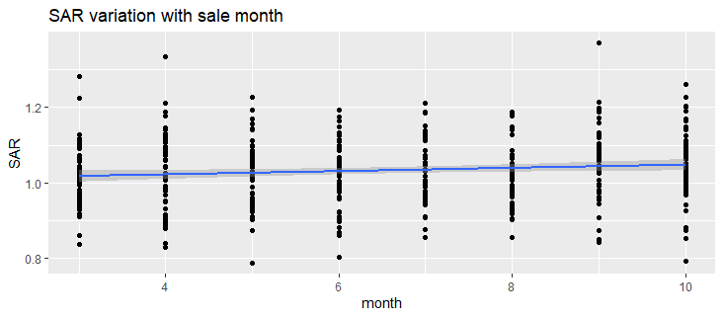
Interestingly, there is a continuous increase in the SAR over the sale period. The correlation, however, is not significant as it is indicated by the value for R² = 0.012. Therefore, it would be more appropriate to apply month adjustment to each month individually, using a non-parametric approach. Here, I use Kruskal-Wallis test for this purpose: the test determines if there is a significant difference between how SAR ranks are distributed between months.
Rank
SAR | Sale Month | N | Mean Rank
 | 3 | 56 | 196
 | 4 | 62 | 222
 | 5 | 51 | 221
 | 6 | 66 | 208
 | 7 | 51 | 237
 | 8 | 50 | 198
 | 9 | 48 | 254
 | 10 | 62 | 256
 | Total | 446

Test Statistics: Kruskal-Wallis – Grouping by Sale Month
 | SAR
Chi-Square | 12.674
df | 7
Asymp. Sig | 0.08

The asymptotic significance statistic is 8%, which would not small enough to reject the null hypothesis that the SAR values are equally distributed among months. That is to say, time adjustment is not necessary as the SAR rank between months are not significantly different. Note that this observation is also aligned with low value of R², derived before.

Land Value Evaluation

Calculating Land Residual
I can find the land residual by subtracting time adjusted sale price and time adjusted improved value. Land residual will then be used as the dependent variable for further analysis. First, I check the land residuals to see if there is any strange or outliers. The variation of land residuals with lot size is shown in Figure A.1 in Appendix. The figure shows that the land residuals value increase as lot sizes increase, which is expected. There is also no negative value for the land residual which is good.
Next, I will check if the land residual per square feet of lot size decreases as the lot increases (Land Value theory). As it is shown by the Figure A.2 in Appendix, the value per square fee of lot size decreases as the lot size increase; this is aligned with our expectation. Next, I should make a size adjustment factor so the relationship between the land residual per square feet and the lot size becomes more linear. This will help developing the model later.
Ratio Statistics for Land Residual / Lot Area
Mean |  | 8.08
95% Confidence Interval for Mean | Lower Bound | 7.87
 | Upper Bound | 8.29
Median |  | 7.83
95% Confidence Interval for Median | Lower Bound | 7.58
 | Upper Bound | 8.06
 | Actual Coverage | 95.3%
Minimum |  | 2.18
Maximum |  | 15.58
Coefficient of Dispersion |  | 23.17%
Coefficient of Variation | Mean Centered | 28.34%

Taking the median = 7.83 as the central tendency, I will then compute the size factor as the ratio between the residual land per lot area and 7.83. Figure below shows the relationship between size factor and the lot area ins sq feet; I divide lot size by 10,000 so the model coefficients’ values are in reasonable magnitude.
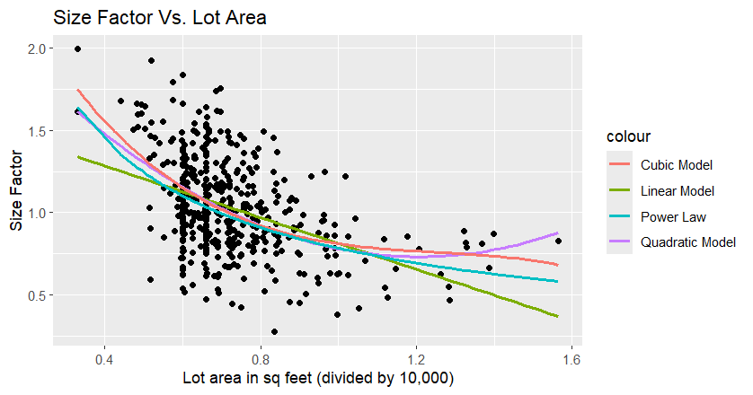
Comparison between Various Models for Size Factor Equations
Equation | R Square | Adjusted R Square | F | Df1 | Df2
Linear | 0.18 | 0.18 | 98.86 | 1 | 444
Quadratic | 0.22 | 0.21 | 61.96 | 2 | 443
Cubic | 0.22 | 0.22 | 42.08 | 3 | 442
Power | 0.20 | 0.20 | 110.80 | 1 | 444

Based on the figure and table above, power model seems to be the appropriate model for size factor. Here are the coefficients for the power model:
$$Size Factor=a × {\left(\frac{lot size}{10000}\right)}^{b}$$
$$a=0.78 | b= -0.67$$
Finally, I make another column in the data for the adjusted lot size as follows:
$$Adjusted Lot Size=Lot Size ×Size Factor$$
Now, I can use the adjusted lot size for the modelling. I am using unit value method for land valuation.

Unit Valuation Method
Following the textbook, I define another column for general land value as follows:
$$Generalized Land Residuals Power Law=Lot Size ×7.83 x Size Factor by Power Law$$
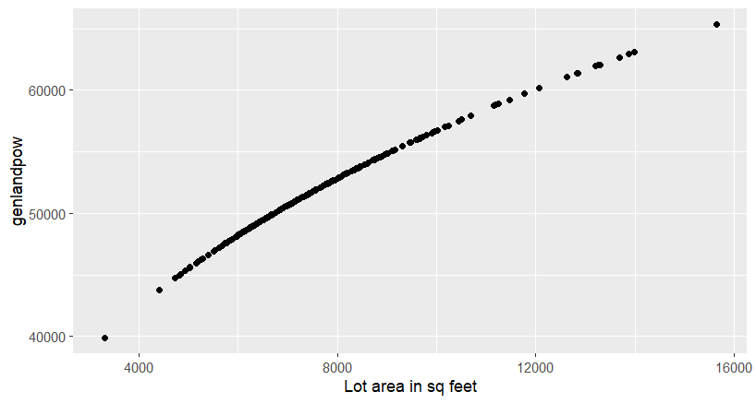
Note that 7.83 is the median of land residual per square feet. Tehe general land value above give us an estimate of the land residual to work on. To ensure valuation is equal across various land characteristics, I run Mann-Whitney test to binary land characteristics.
Mann-Whitney Results – general land value
Variable | Value | Number | Mean Rank | Ays. Significance
corner | 0 | 378 | 220 | 0.20
 | 1 | 68 | 242
culdesac | 0 | 417 | 219 | 0.00
 | 1 | 29 | 285
alley | 0 | 301 | 249 | 0.00
 | 1 | 145 | 171
wooded | 0 | 410 | 225 | 0.42
 | 1 | 36 | 207
pie_shpe | 0 | 420 | 219 | 0.00
 | 1 | 26 | 293
slope | 0 | 389 | 225 | 0.55
 | 1 | 57 | 214
abv_road | 0 | 367 | 228 | 0.11
 | 1 | 79 | 202
The table above shows that the general land value may not be equally distributed between various groups. In particular, the value is not equally distributed with respect to `culdesac`, `alley`, and `pie_shpe` with 95% significance level. Culdesac, pie_shpe and alley show to have a strong correlation with each other; that is expected since lots with culdesac are more prone to be pie_shape and they most likely do not have alley. However, adjustments are likely needed for both culdesac and alley as there is only one lot with both alley and culdesac features.
Lots with Culesac tends to have pi_shpe lots with no Alley
 |  | Alley |  | pi_shpe
Culdesac |  | 0 | 1 | 0 | 1
0 |  | 273 | 144 | 404 | 13
1 |  | 28 | 1 | 16 | 13
 | Chi-squared p.value = 0.00 |  |  | Chi-squared p.value = 0.00

Ratio Statistics for landresid/gelandpow
Culdesac | Alley | Median | Lower Bound | Upper Bound | Actual Coverage | Minimum | Maximum | COD
0 | 0 | 1.01 | 0.97 | 1.05 | 95.52% | 0.37 | 1.76 | 20.51
1 | 0 | 1.20 | 1.06 | 1.26 | 95.72% | 0.18 | 1.58 | 17.24

Table above suggests adjusting general land value for lots with culdesac by (1.20), those without culdesac but with alley by 0.92, and those with neither by 1.10. I repeat the Mann-Whitney tests, and the results (Table A.1) shows that the general land value still needs to be adjusted for alley. Let’s find the ratio statistics for land residual and adjusted general land value for Alley.

Alley | Median | Lower Bound | Upper Bound | Actual Coverage | Minimum | Maximum | COD
0 | 1.07 | 1.02 | 1.10 | 94.26% | 0.15 | 1.75 | 20.34
1 | 0.91 | 0.87 | 0.95 | 94.34% | 0.37 | 1.57 | 19.41

Similarly, the general land value for lots with alley needs to be adjusted by 0.91 and those without alley by 1.07. Doing the same for abv_road, I adjust land value with 0.94 for those with abv_road and finally another adjustment for those with culdesac (1.01) and those without culdesac (0.96) (Corresponding tables are in Appendix)

Which confirms no more adjustments are needed. Finally, I should check if the ratio is equally distributed over the neighbourhoods. Chi squared test shows that there is a significant difference between the neighborhood and further adjustment is needed.
Neigh | Median | Lower Bound | Upper Bound | Actual Coverage | Minimum | Maximum | COD
713 | 1.00 | 0.93 | 1.04 | 95.78 | 0.43 | 1.52 | 17.86
715 | 1.00 | 0.85 | 1.06 | 94.81 | 0.5 | 1.73 | 20.68
716 | 1.00 | 0.96 | 1.04 | 95.26 | 0.47 | 1.46 | 15.47
731 | 1.08 | 0.98 | 1.29 | 95.72 | 0.63 | 1.67 | 19.64
732 | 1.00 | 0.73 | 1.41 | 96.09 | 0.73 | 1.49 | 20.32
734 | 0.99 | 0.83 | 1.07 | 90.77 | 0.66 | 1.59 | 16.96
736 | 1.00 | 0.94 | 1.11 | 96.43 | 0.2 | 1.49 | 20.19
737 | 1.03 | 0.98 | 1.11 | 95.78 | 0.37 | 1.62 | 18.07

I adjusted the ratio for all neighbourhoods, except 731 and 737 and following is the results. Distribution of land residual ratio after adjustment is available in Appendix (Fig A.2).

Cost Model

Market-based Depreciation Factor
I showed in the previous sections that time adjustments are not needed for sale price and so the improvement value is obtained by subtracting land value calculated from the previous section from the sale price. The obtained improvement value is then divided by sum of all replacement cost new components (i.e., main building, garage, carport, and outbuilding) to results observed depreciation. First, I draw depreciation rate versus effective year to find a model for depreciation.
Observed depreciation over effective year
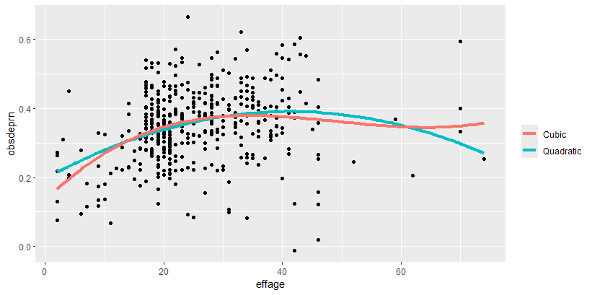

The figure and table above both show that the quadratic model is modelling the depreciation better than cubic transformation. The model shows a decay in depreciation for the effective years above 40 years old which does not seem logical and hence I create another column (effective year 2) which caps effective year at 40 years old. There is also one depreciation less than 0 that needs to be removed. I refit the model after removing the one with negative depreciation and list the coefficients below:
Parameter Estimates
Equation | Constant | b1 | b2
Quadratic | 0.351209 | 0.564770 | -0.497089

The table and figure show that the quadratic curve provides a better fit and the curve looks reasonable. Using the quadratic curve, the depreciation can be found as:
$$Depreciation=0.350393+0.632931 × effage2-0.436044 ×(effage{2)}^{2}$$

$$Percentage Good=1-(0.350393+0.632931 × effage2-0.436044 ×(effage{2)}^{2})$$
Where percentage good is a value between 0-1 where 1 means no depreciation and 0 is full depreciation. The Percentage Good versus Effective Age figure is available in the Appendix (Fig A.3)

RCN Calculation
I can find the Replacement Cost New (RCN) by summing the estimated costs of the main building, garage, and carport. Each component is calculated separately based on the new cost table. First, I determine whether the building is one or two storeys and whether it has a full basement or a crawl space. A full basement is identified if the finished basement area (BMST_AREA) is greater than zero, while a crawl space is identified if the crawl space area (CRWLAREA) is greater than zero. If the second-floor area (FLRAREA2) is greater than zero, the building is considered two-storey.
Next, I apply the base constant costs. For one-storey buildings, the base cost is $51,500 if there is a full basement and $45,500 if there is a crawl space. For two-storey buildings, an additional $16,300 is added to the base cost. I then apply area-based costs. The first-floor area is multiplied by $42.50 per square foot, and if there is a second floor, the second-floor area is multiplied by $33.40 per square foot. Additional costs are added for specific features. If the building has a hot-water heating system (HEATTYPE = 7 or 8), an extra $4.40 per square foot for the first floor and $3.30 per square foot for the second floor is included. Fireplaces add $3,850 each, and bathrooms add $4,000 each. Once the total raw cost for the main building is calculated, it is adjusted by the main building class factor. For example, if the building class (MBMANCLS) is in the range of 40 to 42, the factor is 0.507; if it is in the range of 140 to 142, the factor is 1.000. The raw cost is multiplied by this factor to get the final main building RCN. Next, I calculate the garage and carport costs separately. Garage costs are determined based on garage type and area. A detached garage has a base cost of $16,300 plus $30 per square foot, while an attached garage has a base cost of $11,600 plus $30 per square foot. If the garage is located in the basement, a fixed cost of $7,100 is applied. This raw cost is then adjusted using the garage quality factor, where lower-quality garages have a factor of 0.450, and higher-quality garages have a factor of 1.420. For carports, the base cost is $5,850 plus $22 per square foot of carport area. The final carport RCN is obtained by applying the carport quality factor, similar to garages.
Finally, the total RCN is found by summing the RCN values for the main building, garage, and carport. The calculated RCN value is then multiplied by depreciation (percent good) to find the improved residual values. Next, I am comparing the derived improved value with improved residual value.

Developing Improvement Value
Ratio Statistics for imprrsid / imprcnld
Mean |  | 1.29
95% Confidence Interval for Mean | Lower Bound | 1.27
 | Upper Bound | 1.31
Median |  | 1.29
95% Confidence Interval for Median | Lower Bound | 1.26
 | Upper Bound | 1.31
 | Actual Coverage | 94.79%
Minimum |  | 0.52
Maximum |  | 2.29
Coefficient of Dispersion |  | 13.91

The table above shows the imprcnld should be adjusted by 1.29 (median) to be better comparable with imprrsid. Therefore,
$$Adjusted Depreciated RCN=1.29 ×RCN × Percentage Good$$
The ratio statistics changes as follows, after adjustment

Ratio Statistics for imprrsid / imprcnld_adj
Mean |  | 1.00
95% Confidence Interval for Mean | Lower Bound | 0.99
 | Upper Bound | 1.02
Median |  | 1.00
95% Confidence Interval for Median | Lower Bound | 0.98
 | Upper Bound | 1.02
 | Actual Coverage | 94.79%
Minimum |  | 0.41
Maximum |  | 1.78
Coefficient of Dispersion |  | 13.91

Testing Building Characteristics
First, I test the adjusted ratio for various building stories. Using the project description, the last digit of main building manual class indicates the number of stories. I define
$$mkfact1=imprrsid / imprcnld_adj$$
Ranking for Mkfact1 versus Stories
Mkfact1 | storey | Number | Mean Rank
 | 0 | 411 | 223
 | 1 | 12 | 277
 | 2 | 15 | 213
 | 5 | 4 | 237
 | 7 | 3 | 73.7

Kruskal-Wallis test for Mkfact1 versus Stories
 | Mkfact1
Kruskal-Wallis H | 2.94
df | 2
Asymp. Sig | 0.23

Note than I merged those folios with 5 or more stories with 2 stories to ensure I do have enough folios in each group. The results of Kruskal-Wallis test shows that there does not seem to be a significant difference between the mkfact1 between stories. Next, I am repeating the same process with quality classes.

Ranking for Mkfact1 versus Quality Class
Mkfact1 | Quality Class | Number | Mean Rank
 | 4 | 8 | 284
 | 5 | 3 | 79
 | 8 | 45 | 228
 | 9 | 215 | 201
 | 14 | 168 | 246
 | 15 | 6 | 315

Kruskal-Wallis test for Mkfact1 versus Quality Class
 | Mkfact1
Kruskal-Wallis H | 6.33
df | 4
Asymp. Sig | 0.18

Likewise, I merged the quality classes 4, 5, and 15 to ensure there are enough number of folios in all groups. Kruskal-Wallis shows that the mkfactr1 is equally distributed among the quality classes too. Next, I check the split-level factor for equal distribution of mkfact1.
Ranking for Mkfact1 versus Split-level
Mkfact1 | Split Level | Number | Mean Rank
 | 0 | 411 | 219
 | 1 | 34 | 277

Kruskal-Wallis test for Mkfact1 versus Split-level
 | Mkfact1
Kruskal-Wallis H | 6.52
df | 1
Asymp. Sig | 0.01

Ratio Statistics for Mkfact1 based on Split-level
Split-level | Median | Lower Bound | Upper Bound | Actual Coverage | Minimum | Maximum | COD
0 | 0.99 | 0.97 | 1.01 | 95.54 | 0.41 | 1.78 | 13.82
1 | 1.09 | 0.97 | 1.18 | 95.90 | 0.67 | 1.32 | 12.53

Kruskal-Wallis test shows there is a significant difference between market factors of properties with and without split. I adjust the market improvement RCN using the median of market factor for each group (Mkfact2). Table A.4 shows the adjustment is done correctly.
Repeating the same for garage type, I find out that an adjustment for garage type is needed too as the Kruskal-Wallis test shows significance below 5%. The new market factor is named Mkfact3.
Ratio Statistics for Mkfact2 (adjusted by Split-level) based on Garage Type
Garage Type | Median | Lower Bound | Upper Bound | Actual Coverage | Minimum | Maximum | COD
0 | 1.01 | 0.98 | 1.03 | 94.4 | 0.41 | 1.79 | 13.51
1 | 0.99 | 0.94 | 1.04 | 95.64 | 0.73 | 1.33 | 11.45
2 | 0.89 | 0.84 | 0.94 | 93.73 | 0.58 | 1.37 | 14.86
3 | 1.09 | 1.02 | 1.13 | 96.49 | 0.79 | 1.42 | 9.98

Table A.5, Table A.6, and Table A.7 shows the ratio statistics after adjustments above for number of bedrooms, carport, and family room and they show more adjustments are needed. I run few more tests to ensure no further adjustments are needed.
Variable | Kruskal-Wallis Test p_value
Carport | 0.32
Fireplaces | 0.26
Bedrooms | 0.94
Baths | 0.42
Basement | 0.63
Garage Manual Class | 0.33
Carport Manual Class | 0.27
Heat Type | 0.05

Final Analysis and Conclusion

Model Calibration and Testing
Final Cost Value is obtained by adding the land value found by unit valuation method with the adjusted depreciated RCN I derived above. Comparing it with the sale price

Sale Price Vs. Cost Value
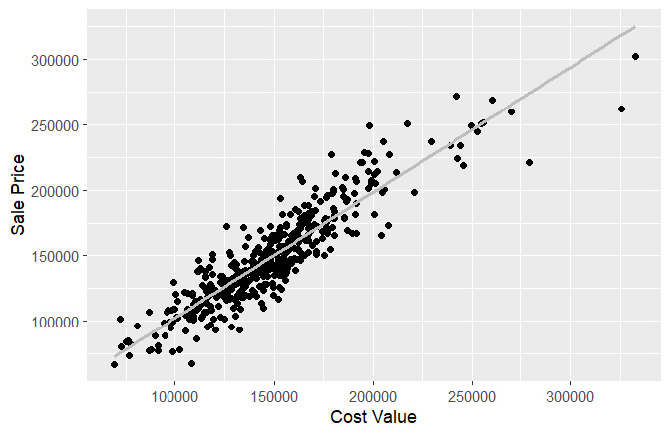
$$R^{2}=0.83$$
Judging based on the R², there is a very good relationship between Sale Price and Cost Value. Table below shows the ratio statistics for the ratio between Cost Value and Sale Price.
Ratio Statistics for ASR (Cost Value / Sale Price)
Mean |  | 1.01
95% Confidence Interval for Mean | Lower Bound | 1.00
 | Upper Bound | 1.02
Median |  | 1.00
95% Confidence Interval for Median | Lower Bound | 0.99
 | Upper Bound | 1.01
 | Actual Coverage | 94.79%
Minimum |  | 0.71
Maximum |  | 1.6
Coefficient of Dispersion |  | 8.01

Neighborhood Analysis
Neigh | Median | Lower Bound | Upper Bound | Actual Coverage | Minimum | Maximum | COD
713 | 1.01 | 1 | 1.04 | 0.71 | 1.3 | 95.78 | 7.76
715 | 1.02 | 1 | 1.04 | 0.8 | 1.31 | 94.81 | 7.44
716 | 1 | 0.99 | 1.02 | 0.79 | 1.26 | 95.26 | 6.32
731 | 0.89 | 0.83 | 0.91 | 0.73 | 1.09 | 93.86 | 8.46
732 | 1 | 0.78 | 1.06 | 0.78 | 1.07 | 96.09 | 7.41
734 | 1.22 | 1.17 | 1.3 | 0.99 | 1.6 | 90.77 | 9.57
736 | 0.97 | 0.93 | 1.02 | 0.83 | 1.13 | 96.43 | 6.87
737 | 0.97 | 0.95 | 1 | 0.78 | 1.3 | 95.78 | 7.46

 | ASR
Kruskal-Wallis H | 65.73
df | 7
Asymp. Sig | 0.00

Which shows an adjustment is needed for the neighborhood. After adjustment, I review the ratio statistics for adjusted ASR:
Ratio Statistics for Adjusted ASR (by Neighborhood)
Mean |  | 1.01
95% Confidence Interval for Mean | Lower Bound | 1.00
 | Upper Bound | 1.02
Median |  | 1.00
95% Confidence Interval for Median | Lower Bound | 0.99
 | Upper Bound | 1.01
 | Actual Coverage | 94.79%
Minimum |  | 0.71
Maximum |  | 1.34
Coefficient of Dispersion |  | 7.32

Which looks very good. Finally, I check if the ASR is equally distributed among various attributes of building and land. Overall, low COD shows there should not be a major vertical inequality in the assessment. First, let’s compare the ASR for various living and land areas:
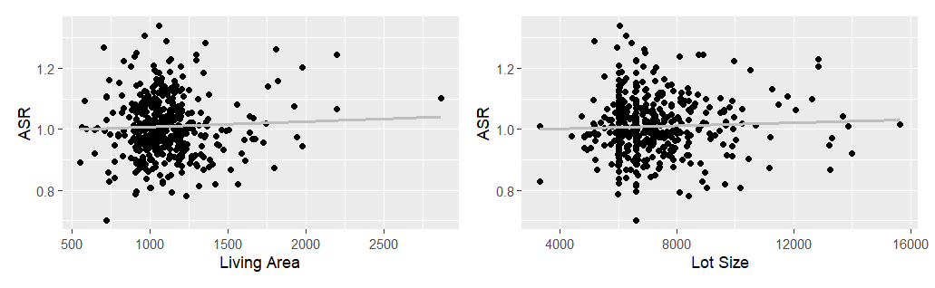
$$R^{2}=0.00$$
$$R^{2}=0.00$$
While large buildings and lands seem to be slightly overvalued, the difference does not seem to be significant based on the R². I repeat the same process for the categorical features too by putting box plot
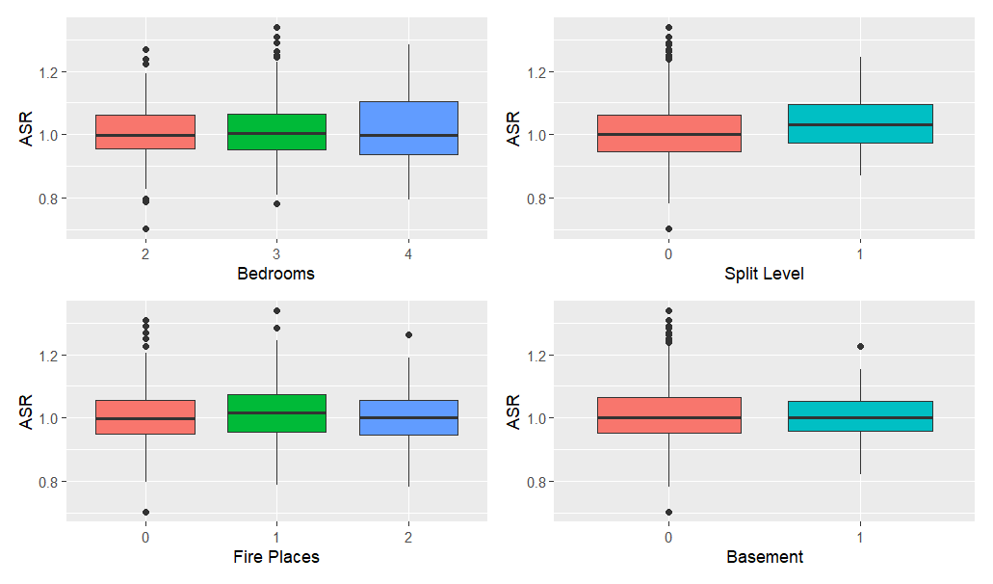
Again, the ASR seems to be equally distributed among the categorical features too.

Conclusion
The final cost valuation demonstrates acceptable performance, with a median Assessment-to-Sales Ratio (ASR) of 1 and a Coefficient of Dispersion (COD) of 7.32%, both meeting IAAO standards. Land valuation utilized the unit value method, while improvement valuations were derived from Replacement Cost New (RCN) data, incorporating appreciation and market adjustments. Throughout the process, necessary adjustments were made to account for specific property characteristics and market variations. Statistical tests and figures confirm the model's consistent application across diverse building and land features. Furthermore, the observed minimum and maximum ASR values fall within a reasonable range, signifying the model's effective operation as intended.

